[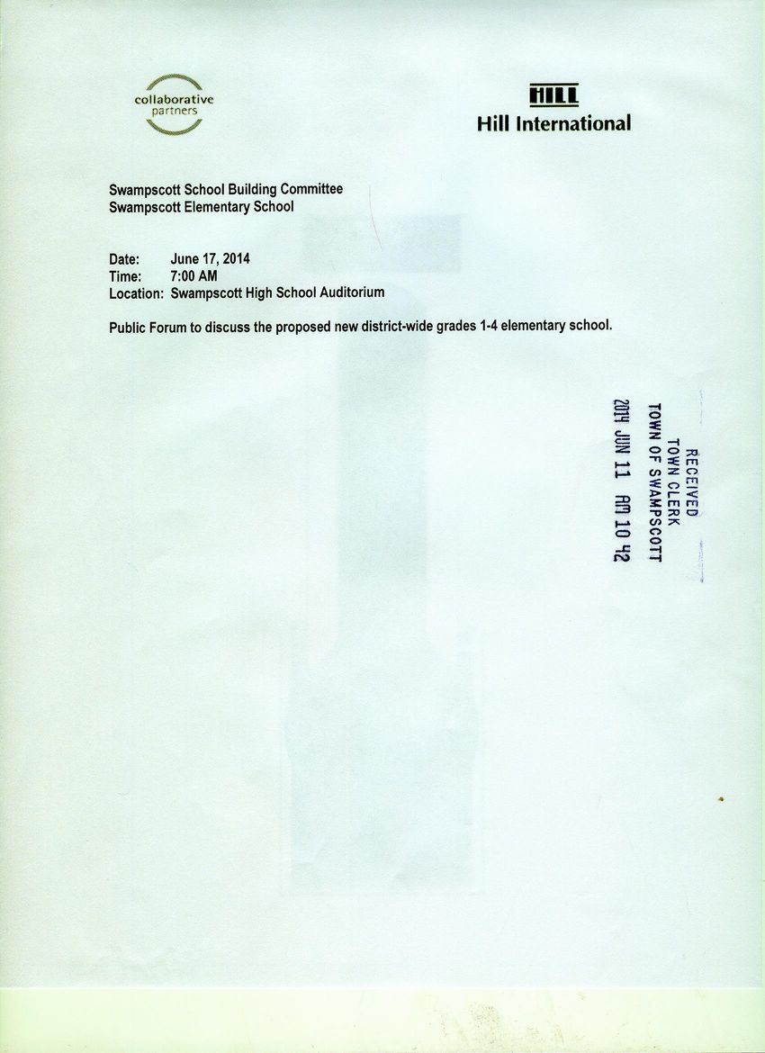](http://www.town.swampscott.ma.us/Public_Documents/SwampscottMA_Calendar/S048D41D2-048D6E7F.0/School%20Building%20June%2017th%20notice%20001.jpg)